VITAMIN B12 AND B12 COENZYMES
Learning Objectives
Content:
- To review the structure of Vitamin B12 in terms of metal-ligand coordination and chemistry
- To understand the role of vitamin B12 in biology
Process:
- To be able to understand the chemistry of cobalt in vitamin B12
- To be able to apply concepts to new situations
Prior Knowledge: Core Inorganic Chemistry Course, Core Organic Chemistry Course

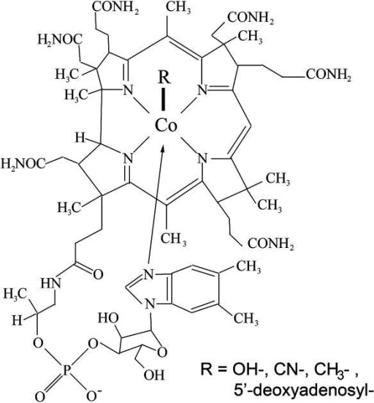
Vitamin B₁₂ or cyanocobalamin is a metallobiomolecule containing cobalt (III) which is at the centre of a macrocyclic corrin ring. The corrin ring is a modified porphyrin ring. The Co(III) ion is in low spin state. The cobalt in the reduced state gives rise to the (r) and the (s) forms of vitamin B12

1) What are the ligands coordinated to the metal?

2) What is the magnetic nature of the Co(III) ion?

3) Give the possible derivatives of Vitamin B12

4) What is the oxidation state of cobalt in vitamin B12 (r) and vitamin B12 (s) forms? Comment on the magnetic nature of the metal ion in these 2 forms.

5) vitamin B12 coenzyme can be derived from vitamin B12 by the following reaction sequence. Complete the reaction?
+2e ?
Co(III)Vit B₁₂ Co(III) adenosyl Vit B₁₂

Role of Vitamin B12
a) alkylation of organic compounds and metals:
Complete the following reactions;
i) Co(II) B₁₂ (r) + RI ? + ?
Co(I) B₁₂ (s) + RI ? + ?

ii) ? + X CH₃X + ? (note: X is any organic grp/metal)

b) Isomerase activity: enzymes with Co(III)B₁₂ cofactor can cause exchange of groups on vicinal carbon atoms of the substrate.
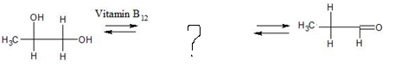

c)Deamination reaction: VitB12 containing enzymes can cause deamination reactions converting amino alcohols into aldehyde.
